daily: festival, weekday and weekend (Friday sat sun)

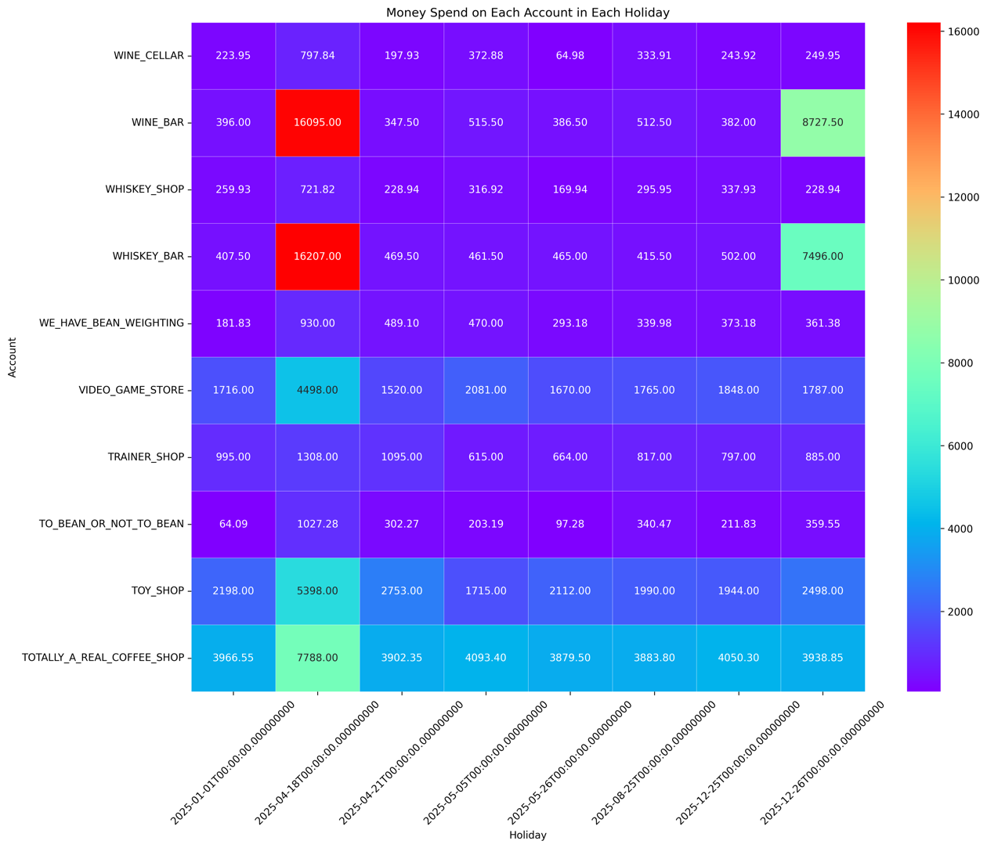

This heatmap shows the top ten businesses in each holiday, people tend to spend money on WINE_BAR and WHISKEY_BAR more than 2 times of other businesses. The trend remains consistent even on Boxing Day, where these alcohol-related venues maintain their dominance in customer spending. This finding suggests that there is a cultural association between celebration and parties with alcoholic beverages.

Clearly, people allocate a portion of their expenditure toward these specific businesses. Recognizing alcohol-related spending throughout the year can make us market suitable strategies for customer preference.

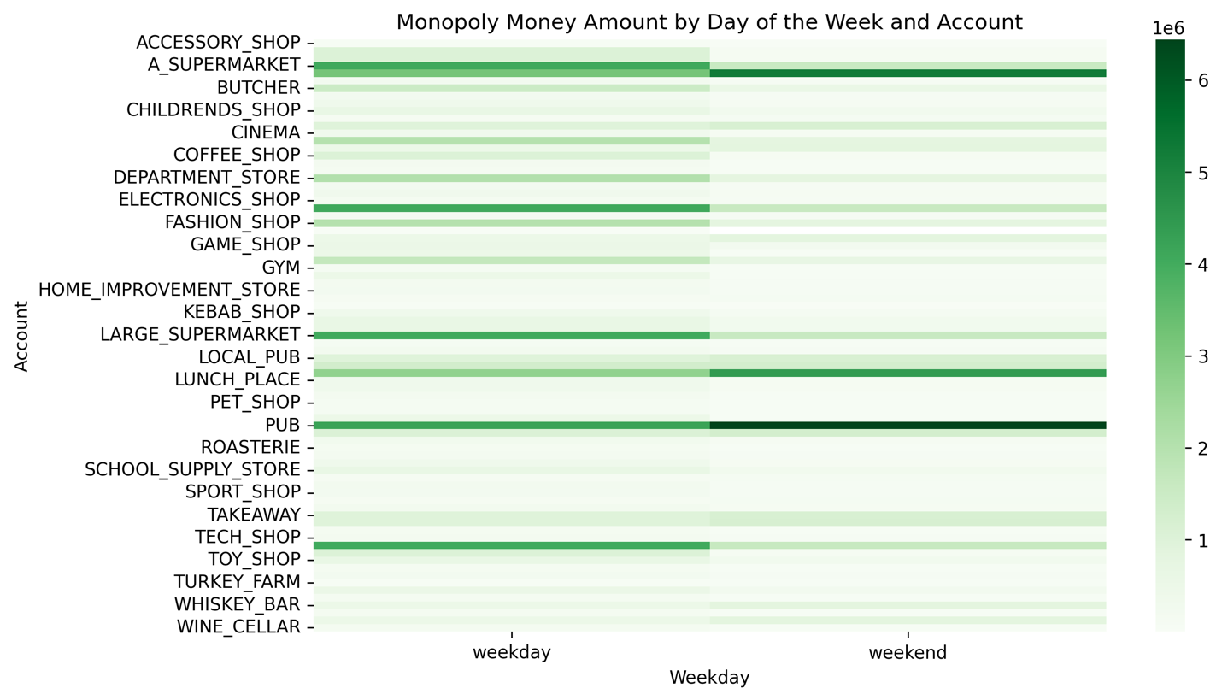In normal day, alcohol-related businesses still gain a lot of money from people in weekend followed by supermarket; however, in weekday people mostly spend money on Supermarket and Electronic.

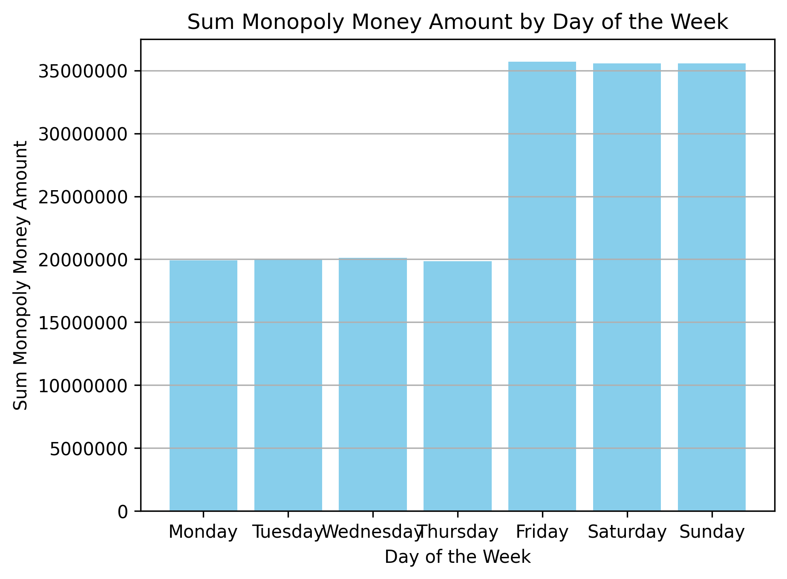

Clearly, most of the business income is on Friday to Sunday, related to pub and bar income because people go to pubs when tomorrow is free. So, it is unsurprised that why people spend money more on Friday to Sunday.

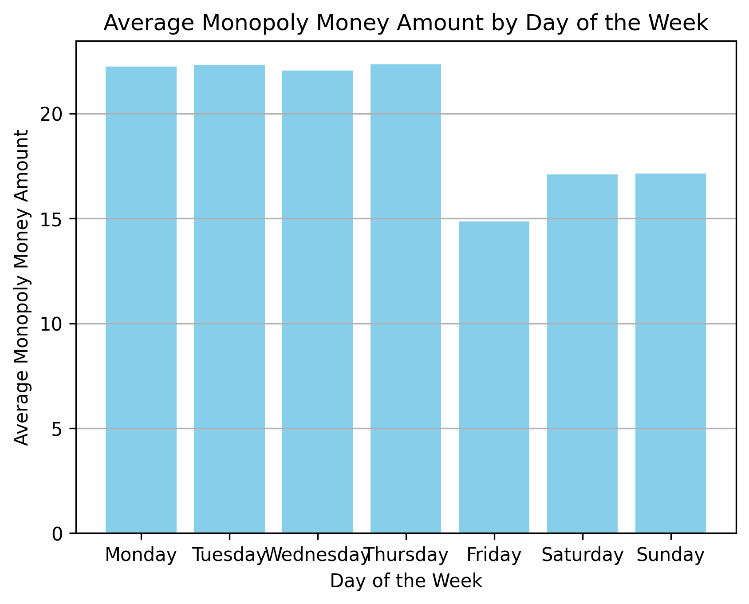

monthly: feb increase, month-end decrease, top 10 store

